PD Calculation 2017/2016

1 - Changes to be done to 2016 portfolio File(Prior Year)
Add Columns and do adjustment for items (a) – (e)
a.) YTM Calculation

1. Get the 2016 portfolio file separately.
2. Add Years to Maturity next to Expiry Date in the 2016 File.
3. Same Formula as Calculation of remaining Maturity in 2017 file

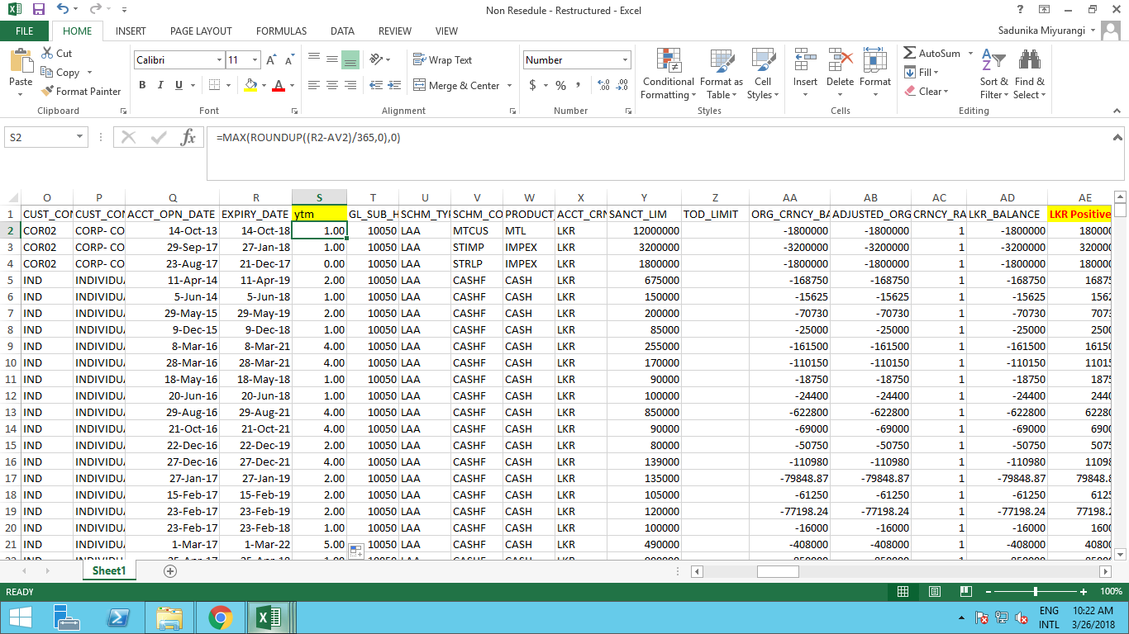

b.) SLFRS Product New Idientification

4. Add SLFRS Product new - Get through VLOOKUP by referring to main portfolio file.

c.) Adding Industry from the Main Portfolio File

5. Add Industry through VLOOKUP by referring to main portfolio file

d.) Adding Arrears Bucket

6. Add Arrears Bucket Based on the Arrears Days Using the Formula Used Above in 2017 Calculation. (Step 51&52-in the rearranging part)

e.) Adding Arrears Months

7. Take the Arrears months from 2017 portfolio File to 2016 Portfolio File by Using VLOOKUP.
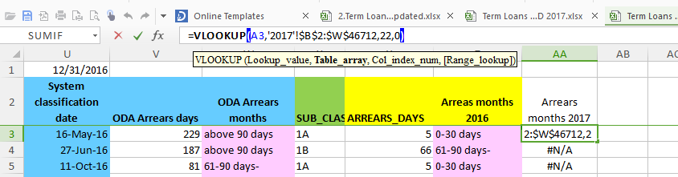

2 - Creating Pivot Table

8. Create a Pivot table from the 2016 Portfolio as Below.

-Arrears months 2016 as Rows
-Arrears months 2017 as Columns
-Values Count of ACCT Num
-Filter
1. YTM
2. SLFRS Product New
3. Industry

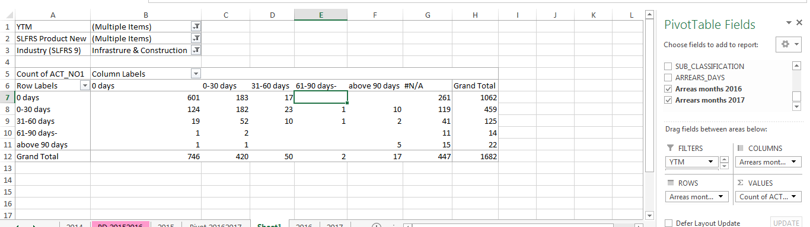

9. Filter Values by Removing YTM 0-1 for 1yr PD
10. Filter by Required Industry
11. Filter by SLFRS Product Code new for Term Loans (LTL & MTL)
12. Convert the Pivot table in to % of Rows.
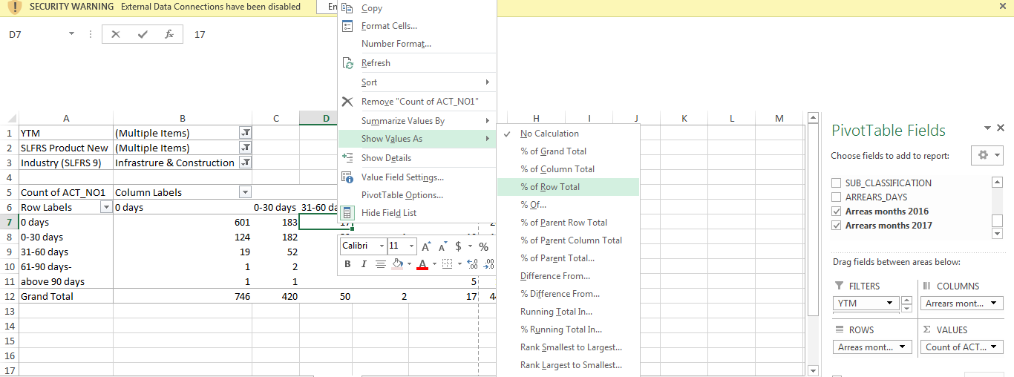

COMPUTE PD

3 – Copy Pivot Table Values to the PD Calculation Sheet.

13. Copy the Values of the Pivot table excluding the NA values to the New Workbook Called TL Industry Wise PD.
14. Copy it to the Relevant Table = 2016/2017
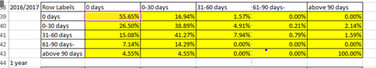
15. Previous Five Years Data is Available as above format and need to be updated.(for the PD Calculation for 1-5 Yrs)
4 – Computation of PD
a.) Compute 1yr Average
16. Calculate the Average in the One Year Average PD table.
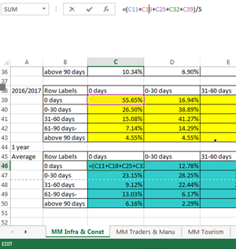

b.) Compute Average for 2 to 5 year by Using MMULT Function

17. Based on the One Year Average PD table Compute the 2 - 5 Year PD by Using the MMULT Function

Use formulas below for all five Tables given

2 Year Average =MMULT (Array1 is 1 Yr Data, Array 2 is 1Yr Data)
3 Year Average =MMULT (Array1 is 1 Yr Data, Array 2 is 2Yr Data)
4 Year Average =MMULT (Array1 is 1 Yr Data, Array 2 is 3Yr Data)
5 Year Average =MMULT (Array1 is 1 Yr Data, Array 2 is 4Yr Data)

5-Compute PD for Each bucket for each year.

18. Above 90 = 100% - (Doesn't Change)
19. 61-90 Days Arrears Bucket PD Calculation
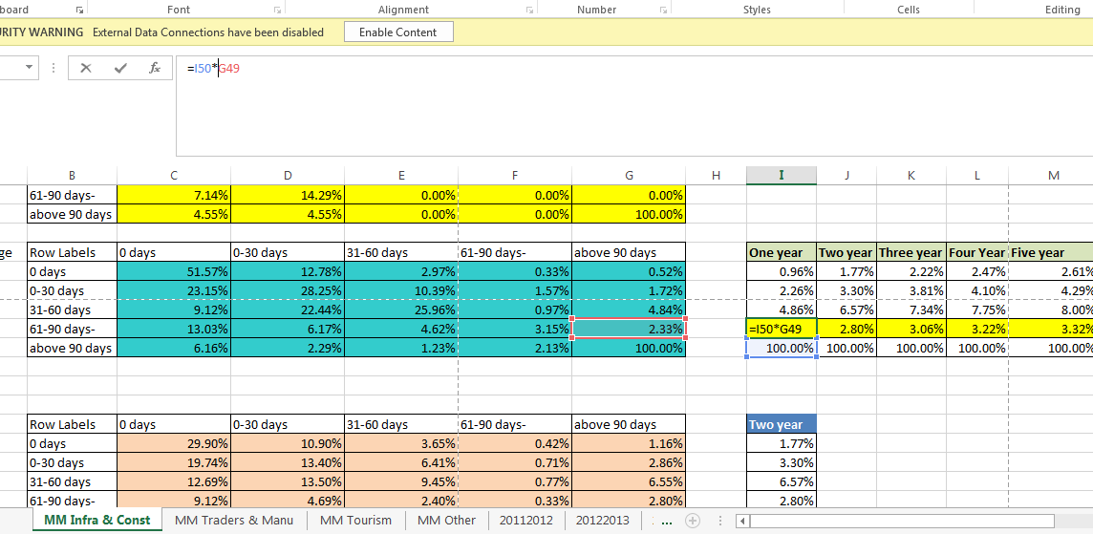
20. 31-60 Days Arrears bucket PD calculation.
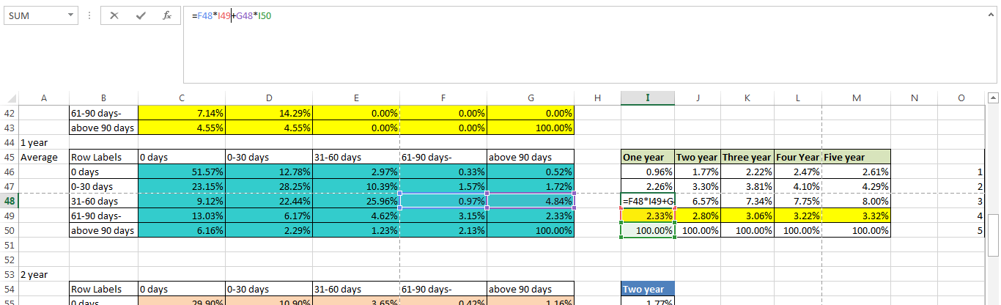
21. 0-30 Days Arrears bucket PD calculation.
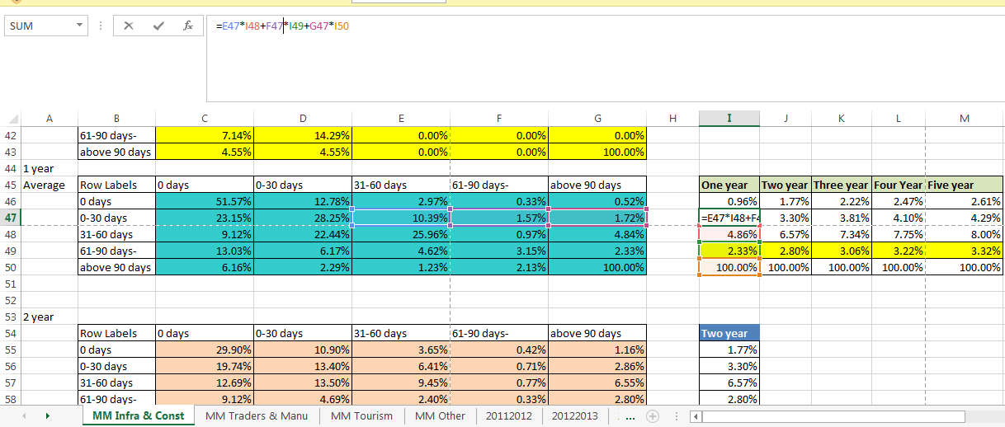

22. PD calculation for 0 Days Arrears Bucket
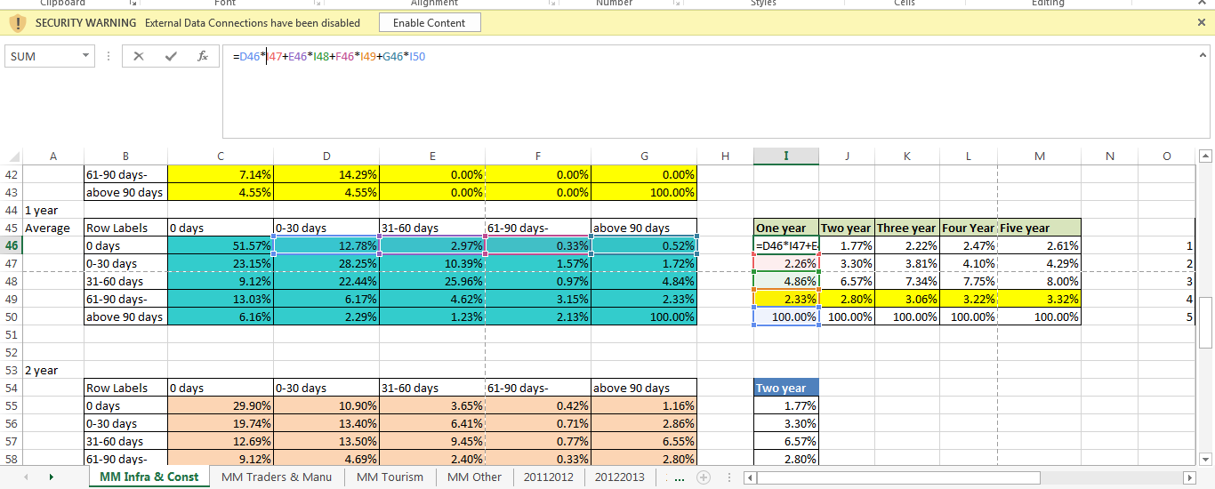

23. Do the Same Calculation Shown above under Each Arrears Bucket for All 5 years

6 – Check PD Trend and Adjust if required

24. Check whether there is an Upward trend with the Increase in the arrears Bucket if Not Shown in the below Illustration.
Illustration-Here 61-90 Arrears Bucket Shows Lower PD than the 31-60 Bucket which is Abnormal.
25. Get the Correct Points and Make a Scatter diagram (Insert a scatter chart) add a trend line using options select exponential
Eg:- According to Above “0 Days”, “0 -30 Days”, “31-60 Days”, “Above 90 Days “Are Showing correct values

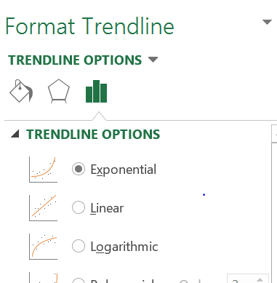

26. Tick Display Equation on Chart
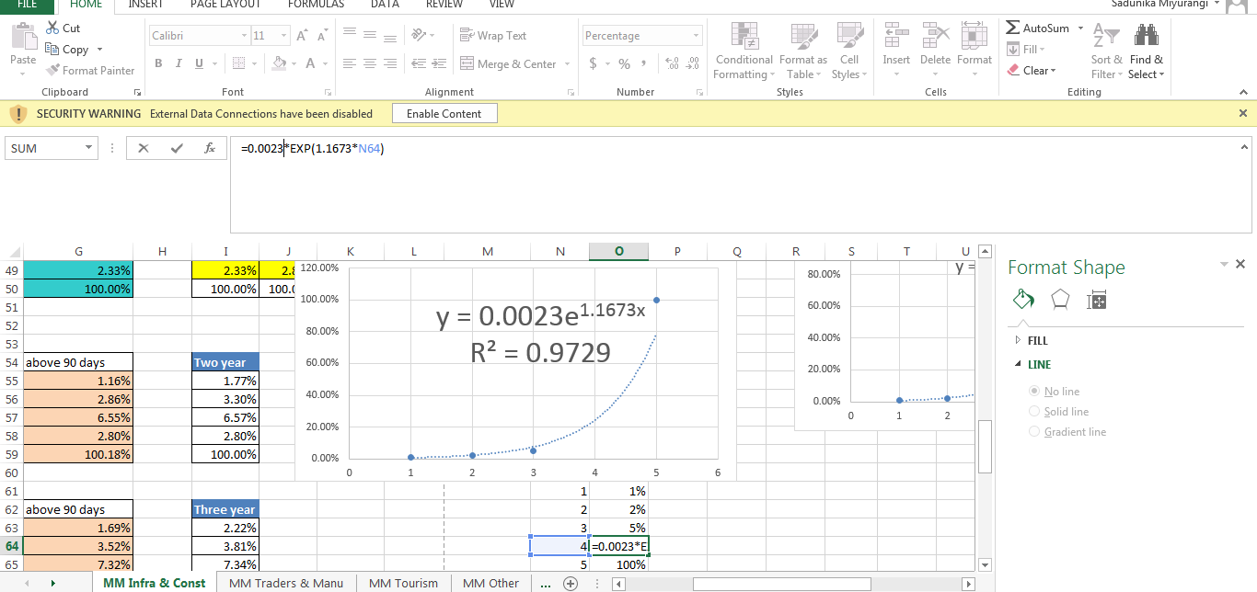
27. Get the Value by Applying Formula of Exponential Chart.
28. Forecast the balance year (Year 2, 3 4, 5) using below formula.
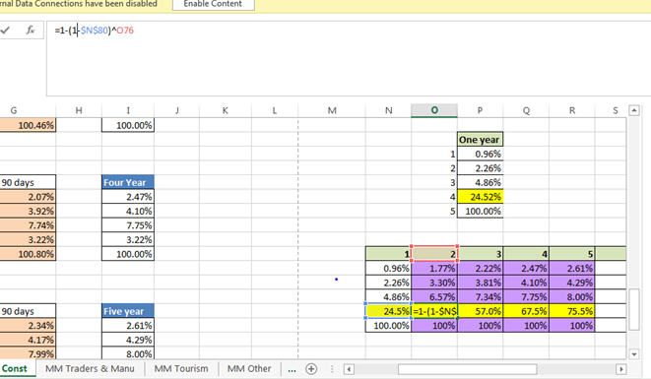

7 - Forecast PD Beyond the 5 years

29. Forecast the PDs for Balance years (PD should Calculate for Each YTM under Each Bucket) Using the below formula.
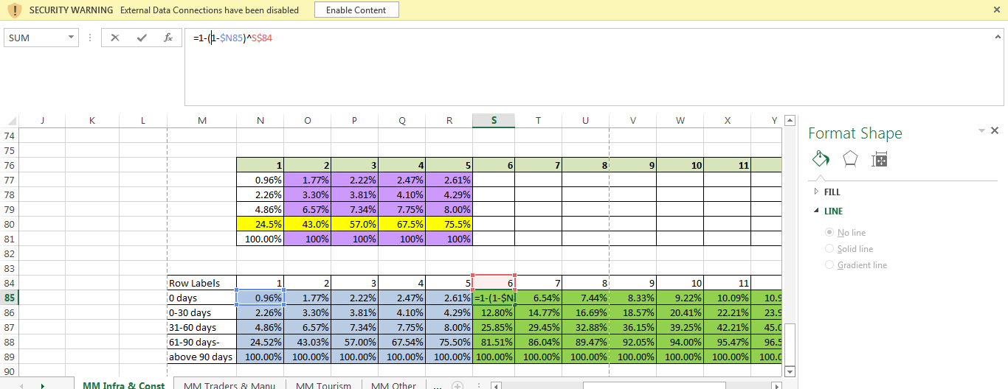

IMPAIRMENT COMPUTATION – Non Restructured Non Rescheduled.

- Update PD Rates Table

8 – Create Pivot table

- Create a Pivot Table As Below.

Illustration - Pivot Table Filters
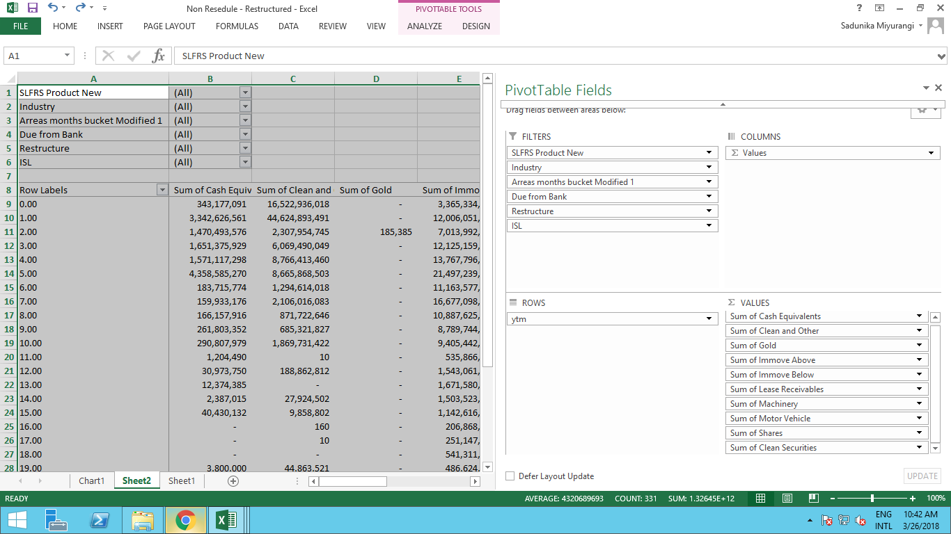

Illustration - Pivot table Fields

9 – Compute for 0 and 0-30 Days
0 Days PD Computation

- Filter Pivot table by SLFRS product new - LTL & MTL(for Term Loans/Term Loans Specified As LTL & MTL)
- Filter the Relevant Industry
- Arrears Bucket for 0 days
- Due From Banks “NO”
- Filter ISL by “NO”

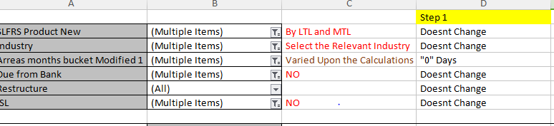

a ).Update Security Details

- Update the Security Wise totals for Computation Sheet in A Separate Workbook for Non Restructured and Non Rescheduled.
Illustration - Computation Sheet.
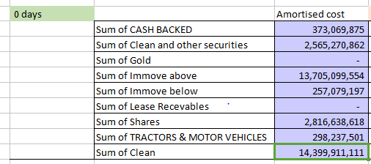

Illustration - Pivot table Data (Need to Replace the Totals for Each Relevant Security in the Computation Sheet)

- Average tenor of the Product is given by the Customer.
- Average Int rate of the Product is given by the Customer.

- Calculate the PV of Payment

- Using PMT Function Calculate the Monthly payment of a 1 rupee

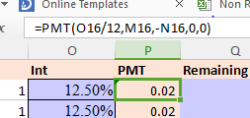

- Calculate the Outstanding Amount By Using PV function

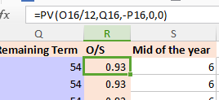

- EAD Computation

- Get the EAD value by Multiplying Security Wise Amortized cost by Outstanding Amount

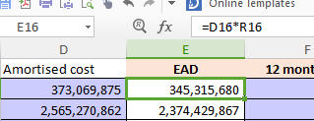

- Take the PD rates, Economic Factor rates (EFA), LGD rates, from relevant Tables, These Tables Need to be provided by Customer.

- Calculation of the Provision and PV of the Provision.

-Impairment Calculation for 0 days

Provision = EAD*PD (0 Days)*EFA*LGD

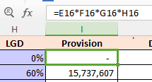

Calculation of Discount Factor using the Below Formula.

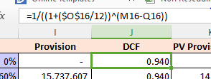

PV of Provision = EAD*PD (0 Days)*EFA*LGD*DCF

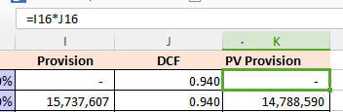

0-30 Days PD Calculation
7. Filter the 0-30 Days Arrears Bucket

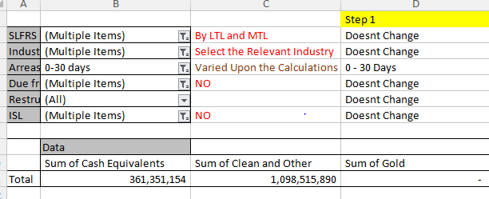

- Update the Relevant table in the Computation Sheet Based on the Pivot Table Results.

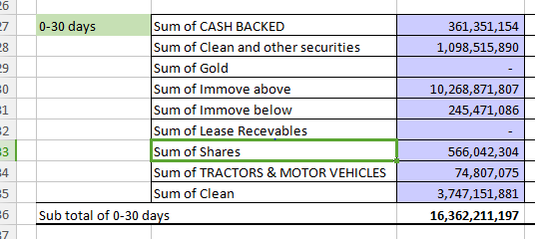

- Follow the Same Steps there After As Done in the 0 Days Computation

-Impairment Calculation for 0 - 30 days
Provision = EAD*PD (0-30 Days)*EFA*LGD

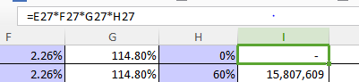

PV of Provision = EAD*PD (0 - 30 Days)*EFA*LGD*DCF

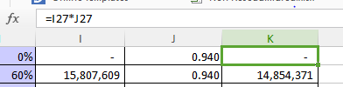

10 - Impairment Calculation for 31-60 Days 61- 90 Days
31-60 Days PD Computation
- Get the Security Value from Pivot table.
- Filter the Arrears Bucket 31-60 days,
- Get the YTM As filter Criteria in the Pivot Table.
- Get the Filtered Values for YTM 0-1

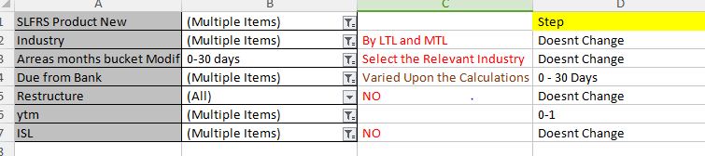

- Update the Computation Sheet for 31-60 and Default Point 1 table.

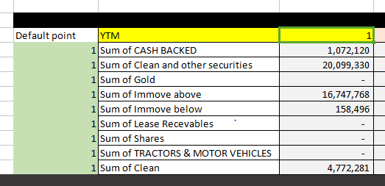

- Filter the Values Again By YTM Value 2

- Update the Default point 1 and 2 Tables By Using the Data in the Pivot Table

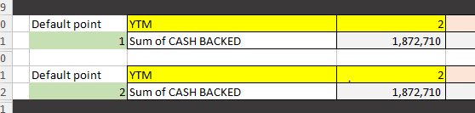

- Filter the Values Again By YTM 3

- Update the YTM 3 Tables by Using the Pivot Table data as above.

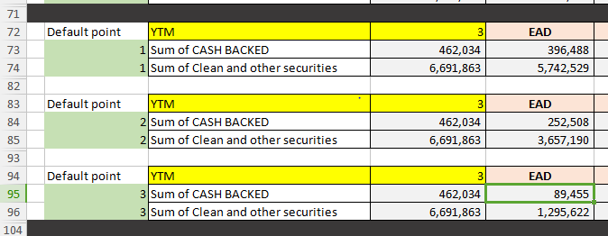

Note - Like Wise For Each YTM there will be equal Amount of Default Points (YTM =3 , Default Points 3) and Need to Calculate the PD Separately For Each Default Point there for the Number of Tables Required under Each YTM is Equals to the Value of YTM

b.)Calculate the PV of Payment

21. TERM of the Loan = YTM*12(No of Months per Year)
22. Interest Rate = Will Be Provided
23. Loan = Always Equals to 1

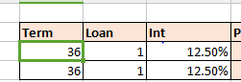

- Calculate the Payment Using PMT Formula As Below.

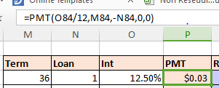

- Get the mid of the Year Value on the Assumption that Default Takes place on the mid of that Year.

=YTM (Default Point)*12-6

- Calculate the Remaining term by deducting Term from the mid of the Year Value.

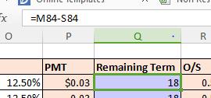

27. Calculate the Outstanding Amount Using PV Formula as Done Previously.

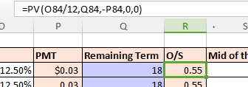

c.)Calculate EAD

- Get the EAD for Each Default Points based on that Result.

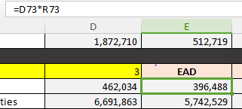

d.)Calculation of Provision and PV of Provision

- Identifying PD for the Calculation
Note-PD Used to Calculate this Arrears Buckets is Incremental PD and that Will be Obtained by Getting 1st Default Point PD as 1 default Point and in the Second Default Point it Would Be PD of YTM 2nd Year - PD of YTM 1st Year Likewise for Each default Point Has to Decide the Incremental PD for Each Based on the Default Point Value.

Illustration-Two Year PD (PD of 31-60 bucket and YTM 1)

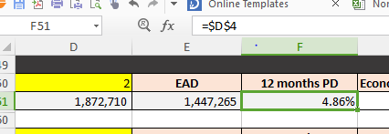

Illustration- PD Table
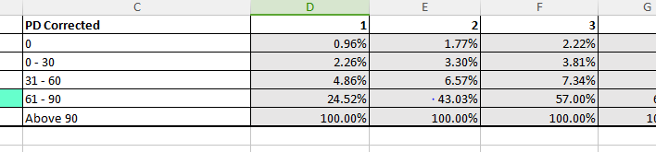

Illustration-Second Default Point PD (31-60 PD for YTM 2 - DP 1 PD)

- Repeat for each YTM
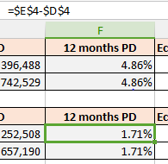

- Economic Factor and LGD will be provided by the Customer.

61-90 Days PD Computation

31. Filter the Pivot Table from 61-90 Days and Do the Same Steps Selected PD should be 61-90 days PD

Impairment Provision Calculation for 31-60 & 61-90 Days.

Provision n= EAD*PD (Relevant Arrears Days and PDn - PD (n-1))*EFA*LGD

PV of Provision n = EAD*PD (Relevant Arrears Days and PDn - PD (n-1))*EFA*LGD*DCF

.n=Default Point (YTM of PD)

Need to do each activity Mentioned Above for All the Default Point Tables Under 31-60 & 61-90 Arrears Buckets.

11 - Impairment Calculation for Above 90 days,

1. Filter the Values of the Pivot table for Arrears Buckets above 90 days
2. Get the total and Paste it to Computation Sheet
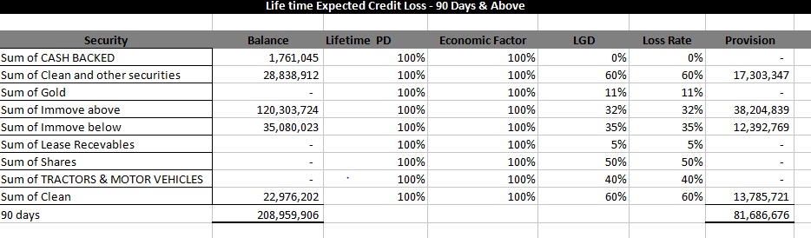

Impairment Calculation

EAD = Amortized Cost
PD=100%
EFA=100%
DCF=1

PV of Provision = EAD*PD*EFA*LGD*DCF

PV provision=EAD*LGD

12 - Impairment Calculation Restructured
All other steps are same Except the Classification of Arrears Buckets
Classify 0 Days and 0-30 days and 31-60 All to be classified as 31-60 in generating the Pivot table. All Other Clarification Are Same

13 - Impairment Calculation for Rescheduled
All other steps are same Except the Classification of Arrears Buckets
Classify 0 Days and 0-30 days and to be Classified as 31-60 in generating the Pivot table.31-60 61-90 and Above 90 All 3 are classified as Above 90.

-Impairment Calculation for 31-60 Days 61- 90 Days

Example YTM = 3

Default Point 1

Term Equals 12*3
Calculate the Payment using the PMT Function Explained above Step 16.
Calculate the Outstanding Balance Using PV Formula.
Identify 3 Default Points
Impairment Calculation for default point 1
Remaining term is 30 for Default point 1
Calculate the PV provision as below

PV of Provision = EAD*PD (31-60 Days and PD YTM = Default Point1)*EFA*LGD*DCF

Impairment Calculation for Default point 2

Remaining term is 18 for Default point 1
Calculate the PV provision as below

PV of Provision = EAD*PD (31-60 Days and PD YTM = Default Point2-DP1)*EFA*LGD*DCF

Same steps for 61-90 Days refer 61-90 Days PD

Impairment Calculation for Above 90 days,

Filter the Values of the Pivot table for Arrear Bucket above 90
And Get the total and Paste it to Computation Sheet
EAD = Amortized Cost
PV of Provision = EAD*PD100%*EFA1*LGD*DCF1

